Basic Structure of a JAVA Program

public class Main {  
 public static void main(String[] args) {  
   
 System.*out*.println();  
 }  
}

Here **main** is the **ENTRYPOINT** into the application.

NAMING CONVENTIONS :-

----> for **CLASSES** -----**Pascal Convention** (First and the Subsequent Characters from a word are UPPERCASE)

For Example: - Sai Teja Chakravarthula

----->for **FUNCTIONS & VARIABLES** -----**camelCase Convention** (First Character is LOWERCASE and the Subsequent Characters are UPPERCASE)

For Example: - sai Teja Chakravarthula

Variables & DataTypes : -

Variable is a container that stores a value which can also be changed during the execution of the program

Example :- int number =8 ;

Here (int is a datatype) ( number is a variable name ) (8 is the value it stores)

RULES FOR DECLARING A VARIABLE: -

1.It Must not begin with a digit

2.Name is CASE SENSITIVE

3.it should not be a KEY WORD

4.SPACE is not allowed

Datatypes in java fall under the following categories

1.Premitive DataTypes (INTRINSIC)

2.Non-Primitive DataTypes (DERIVED)

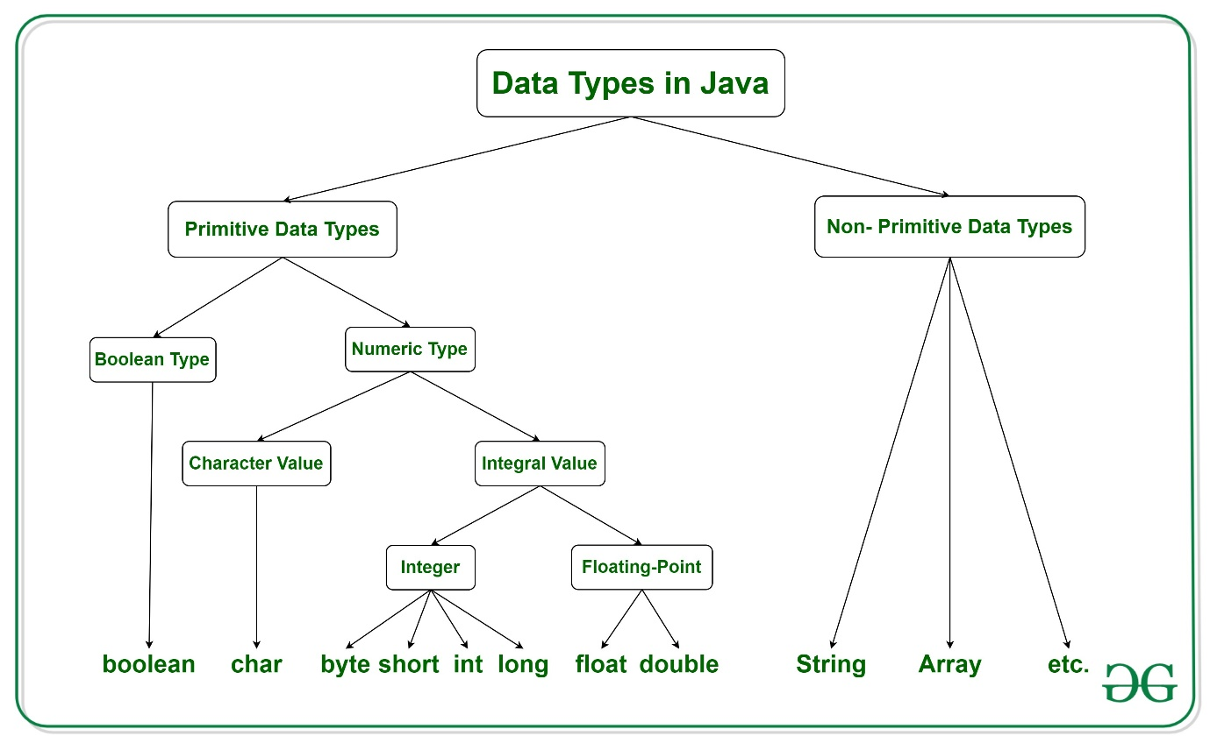

PRIMITIVE DATATYPES: -

There are 8 Primitive Datatypes

1.byte 🡪 Value Ranges from -128 to 127 (**Takes 1byte)**

2.short 🡪value ranges from -(216)/2 to (216)/2 -1 **(Takes 2 bytes)**

3.int 🡪value ranges from -(232)/2 to (232)/2-1 **(Takes 4 bytes)**

4.float🡪up to 7 decimal digits **(Takes 4bytes)**

5.long 🡪value ranges from -(264)/2 to (264)/2 -1 **(takes 8 bytes)**

6.double 🡪upto 16 decimal digits (takes 8 bytes)

7.char 🡪 value ranges from 65535(216 -1) (**takes 2 bytes)**

8.boolean 🡪value can be true or false **(Default value is FALSE)**

In integer data type for all the 4 types if we don’t mention the type then it automatically takes int

But for float data type we have to mention the type as (f or F) & (d or D)

LITERALS: -

A constant value which can be assigned to the variable is called as a literal

101 🡪 INTEGER literal

10.1f or 10.1F 🡪FLOAT literal

10.1 🡪DOUBLE literal (DEFAULT TYPE FRO DECIMALS)

‘A’ 🡪CHARACTER literal

True 🡪BOOLEAN literal

“Teja” 🡪 STRING literal

public class Main {  
 public static void main(String[] args) {  
  
 int a =10;  
 int b =10;  
  
 int A=a+b;  
 int B=a-b;  
 int C=a*b;  
 int D=a/b;  
  
 System.out.println("Sum of a and b is :" + A);  
 System.out.println("Difference of a and b is :" + B);  
 System.out.println("Product of a and b is :" + C);  
 System.out.println("Division of a and b is :" + D);  
  
  
// use sout for System.out.println  
   
   
 }  
}

READING DATA FROM THE KEYBOARD :-

In order to read data from the keyboard ,java has a scanner class . scanner class has a lot of methods to read the data from the keyboard

System.out.println("Taking Input");  
 Scanner sc= new Scanner (System.in);

System.out.print("Enter number1:");  
 int a=sc.nextInt();

System.out.print("Enter number2:");  
int b=sc.nextInt();

int c=a+b;

System.out.println("sum of the numbers :" + c);